|  |
| --- |
| HCL Technologies Ltd. |
| MOTECH – Offline Mode Support |
|  |

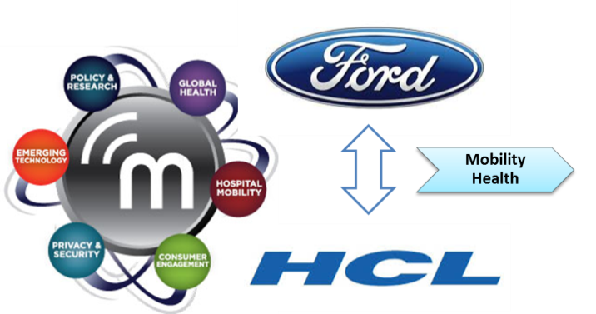

# Overview

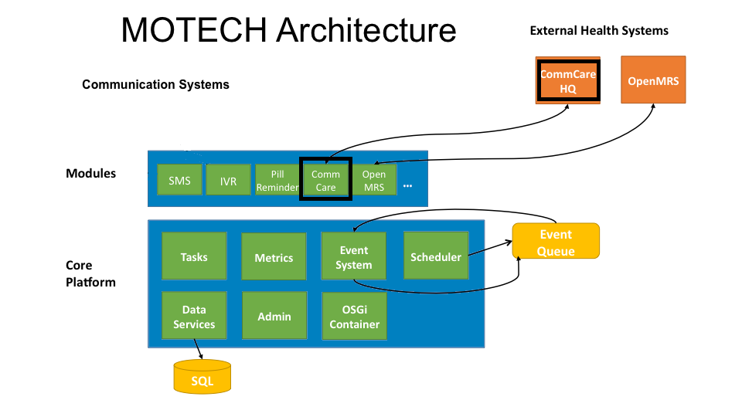

Health worker interacts with MOTECH system through their mobile phone (J2ME or Android). The App that runs on Health worker phone names **‘CommCare ODK’**.

The CommCare ODK is a mobile application that allows health workers to access content and collect data. There are data forms in app, which enable the health worker to enter and upload the data to server. The CommCare UI is a series of forms that walk the caregiver and patient through the information and questions to be covered for a specific appointment protocol.

In addition to presenting information, **CommCare** can be used to input data about the patient’s visit. **CommCare** runs on medium-low capability phones and higher end phones.

**The need for Offline mode support comes primarily at the CommCare ODK Application end. When health worked mobile phone is not observing a cellular network signal, the data collected during the interaction with patients need to be locally stored at the phone; And later as cellular network is available, data in-cache will sync with the Backend server.**

CommCare ODK App in-turn interacts with an intermediate server named ‘CommCare HQ’. **CommCareHQ** is the server component which stores the data collected by the **CommCare handset application**. **CommCareHQ** in-turn communicates with **MOTECH server** to coordinate care between the **two systems**.

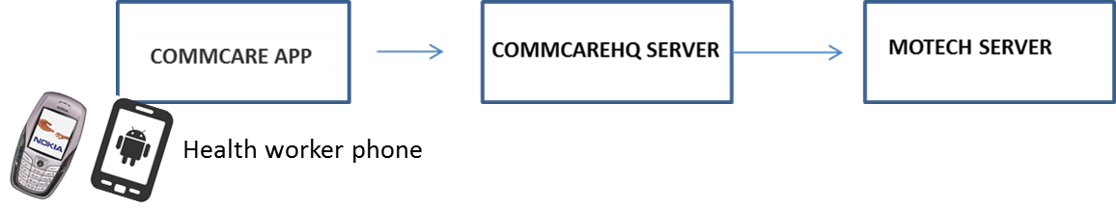The below diagram shows the flow of data from CommCare application to MOTECH Server:

# How CommCare Mobile App works with CommCare HQ Server

The CommCare Mobile App utilizes several open source libraries, including CommCare, CommCareHQ, Open Data Kit (ODK), JavaRosa, Django, RapidSMS.

CommCareHQ is a server which provides a web portal as well that allows you to download generated reports and also keep them in sync with mobile application.

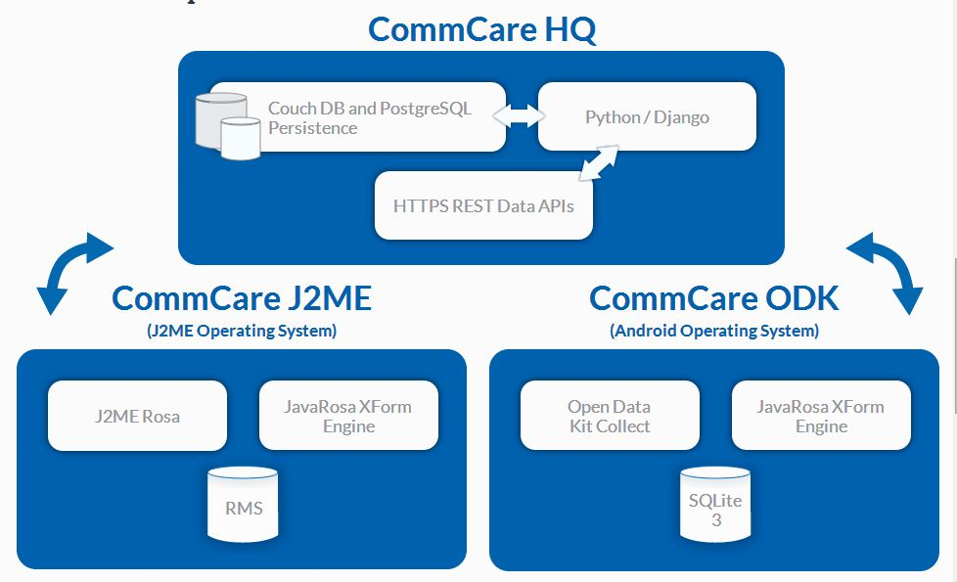

# Communication of CommCareHQ with MOTECH server

## CommCare with Connectivity

Each completed form is saved onto the phone and uploaded to CommCare HQ server. MOTECH server later can fetch and sync up with CommCare HQ server. All data collected with CommCare Mobile is sent over a cellular data network.

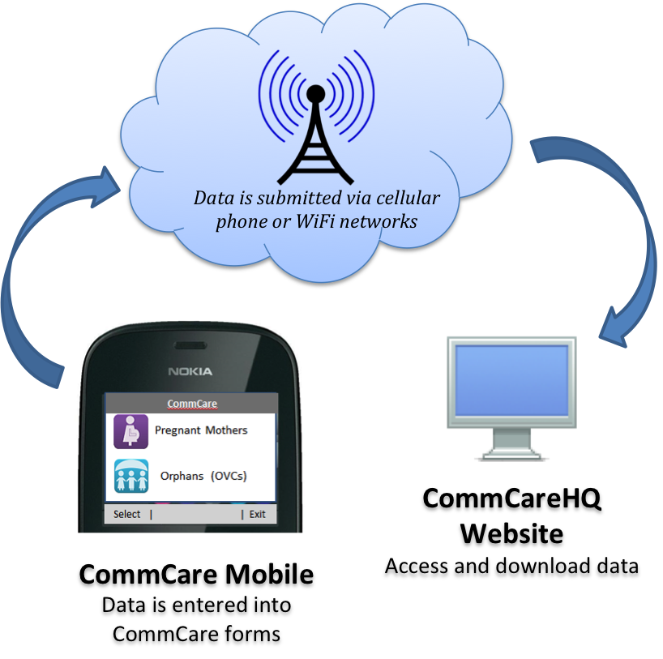

**MOTECH Server**



## CommCare without Connectivity

1. When Internet connectivity is unavailable, CommCare Mobile operates in offline mode and all data collection is unaffected. Data is saved on the phone and can be sent automatically when the phone regains connectivity. All collected data is transmitted to CommCareHQ, where it can be viewed in easy to read reports.
2. Similarly if the network is **unavailable**, outbound messages from MoTeCH to CHOs are saved on the MoTeCH computer servers and sent again when the network becomes available. For messages sent to MoTeCH by CHPS workers, outgoing messages can be stored on the mobile phone and will be sent when the network becomes available.
3. Data collected on a phone when there is no signal, It stays on the phone until there is signal

CommCare was designed to function in places where there is not always consistent access to

network.

1. In Commcare Apps when no Network Connectivity then Data will store through Javarosa xform Engine , OpenDataKit Collect and sqLite3 Database which is store in Internal memory of phone in xml format.

# Technical Design of Offline Mode in ‘CommCare ODK’ Mobile App

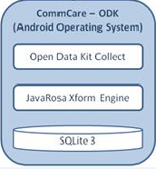The below diagram shows the architecture of Commcare application which help in supporting the offline mode –

**Below are the main components used in CommCare ODK App –**

1. **Open Data Kit (ODK)** is a free and open-source set of tools which help organizations author, field, and manage mobile data collection solutions.
2. [Build](http://opendatakit.org/use/build/) a data collection form or survey .
3. [Collect](http://opendatakit.org/use/collect/) the data on a mobile device and send it to a server; and
4. [Aggregate](http://opendatakit.org/use/aggregate/) the collected data on a server and extract it in useful formats.
5. **JavaRosa Xforms Engine**:

JavaRosa is an XForms client for mobile phones. JavaRosa is an open-source platform for data collection on mobile devices

## Offline Execution Process

1. When the commcare application gets installed, a directory structure is created on sdcard:

Sdcard/Android/data/org.commcare.dalvik/

1. After authentication the below folders are created in above directory structure:

Sdcard/Android/data/org.commcare.dalvik/files/app/folder

1. The folder created in the above directory, contains three sub-folders :

**attachment, commcare** and **formdata**

1. Attachment folder contains all media type resources like image, audio, video.
2. Commcare folder contains all application detail file: logs, install, application details etc.
3. Formdata folder contains all forms which are filled by user, in xml format.
4. Commcare Saves data in encrypted form in xml file with last modification detail, these files are saved in defined folder name on the Internal memory of mobile device

**sdcard/Android/data/org.commcare.dalvik/files/app/653526075645481aa5c2bab2e60bae84/formdata /91be4b02a76d165cbc7cfa4d86ded9767f387ca3_2014-09-24_10_18_48/91be4b02a76d165cbc7**

**cfa4d86ded9767f387ca3_2014-09-24_10-18-48.xml**

1. SQLite Database stores preference for file and other detail like status (completed / incomplete), read only property ,last modification detail.
2. Original filled form data are visible on Javarosa Xforms after that those data are converted into Encrypted form through RSA algorithm on Open Data kit Collect.

## Flow for saving the data

**Diagram showing Data Flow for saving the data on phone**

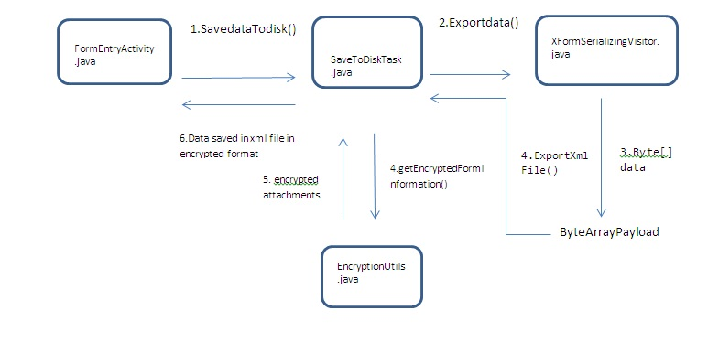

* 1. SavedataTodisk () method Saves data and writes it to disk.
  2. Writes the data to the sdcard, and updates the instances content provider.
  3. A ByteArrayPayload is a simple payload consisting of a byte array.
  4. This method actually writes the xml to disk.
  5. The xml file is then get encrypted and saved

## Flow for sending the data to the server

**Diagram showing Data Flow for sending the data to the server**

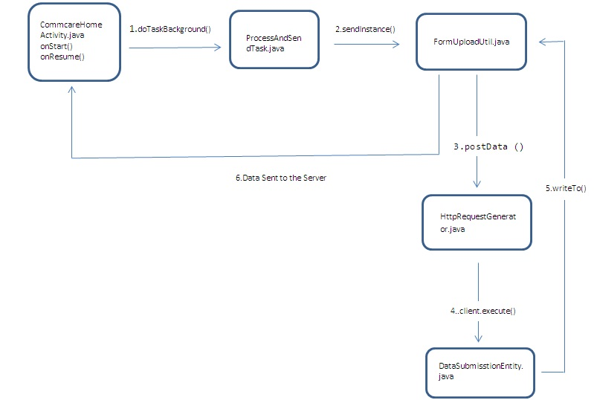

1. Data is not synchronized automatically. When application open then first it check internet

if internet is available then it synchronize the data by calling doTaskBackground() method,

User can synchronize the data by click on Submit Data to server

1. When Commcare Application get internet connectivity, it calls doTaskBackground() method

through AsyncTask.which check unsent or saved file from database.

1. Get folder path and folder’s files path and send it to FormUploadUtil class for getting and decrypting the data by sendInstance() method.
2. FormUploadUtil class check external storage is available or not. if available then decrypt the files and submit it by generating HTTP request.
3. HttpRequestGenerator class is responsible for connection with http client then execute for submitting the data over the server.
4. DataSubmisstionEntity class write the entity on server and get the response from server and
5. Send server response message to CommcareHomeActivity class with notification.

**~~ end of doc ~~**